How to Initiate an Electronic Additional Compensation (eAddl Pay) Form

Log into HR Direct and choose the Department Self Service Homepage.
- Choose Department Self Service

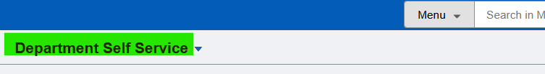

Next, click on the Additional Compensation Tile
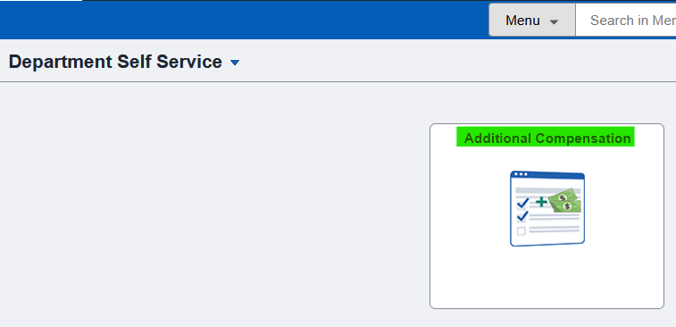

Click on Begin Additional Pay Request
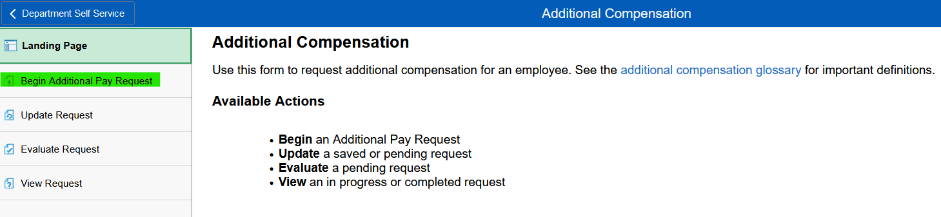

Enter Employee ID (preferable) and/or First/Last Name (these fields are not case sensitive)
Then choose Search
- IF there are multiple employees and/or record numbers with your Search Criteria, you will see a listing of those employees/records. Please click on the correct employee ID/name and record number. If there is only one employee matching your search criteria, you’ll be taken directly to the form.
- This Search will only pull up currently active employees
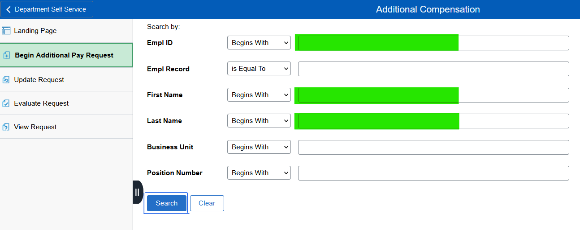

Verify you have opened the form for the correct employee and employee record
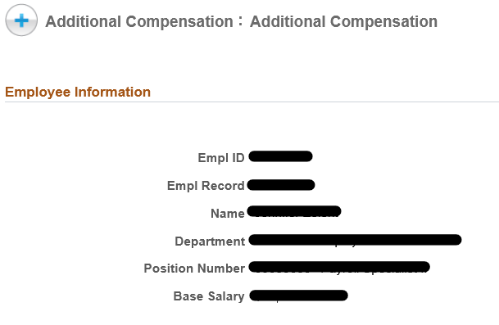

Complete all fields under Additional Pay Request section.
As you choose different values, the page may update for additional needed information. See specifics below. Note: only one funding source will be allowed per form. If multiple funding sources are needed, additional Ad Comp Forms will need to be initiated.
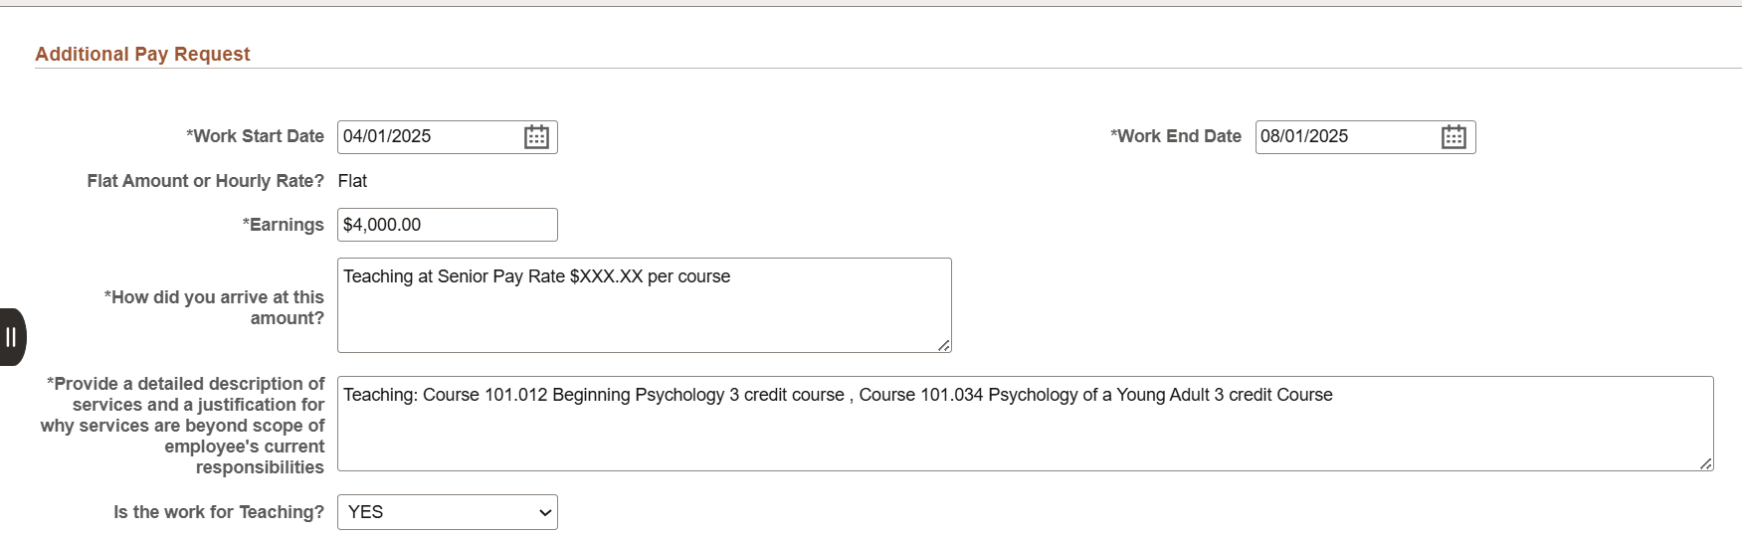
Work Start Date: Begin date employee started working or will start working these duties. If the payment is not date related (ie: bonus), please enter the current pay period begin date.

Work End Date: Last date the employee is expected to complete these duties.

Flat Amount
  - Indicate total amount the employee is expected to receive
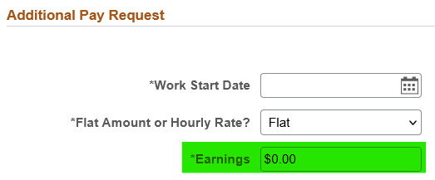

How did you arrive at this rate: Please include information on how you determined the rate the employee is expected to receive.

*Provide a detailed description of services and a justification for why services are beyond scope of employee's current responsibilities. This section should be used to clearly state the details of the work the employee will be preforming. Examples: Teaching: Course XXXX, Development Fee: XXXX, Advising: XXXXX, Teaching Overload: XXXXX.

Is this work Teaching: Select YES or NO

Next, input Funding
Note: only one funding source will be allowed per form. If multiple funding sources are needed, additional Ad Comp Forms will need to be initiated.

Choose correct Business Unit
Enter Combination Code
- If needed, click on the magnifying glass to assist with finding the Combination Code
  - Input any or all known fields
  - Click Search
  - Choose correct Combination Code under Search Results
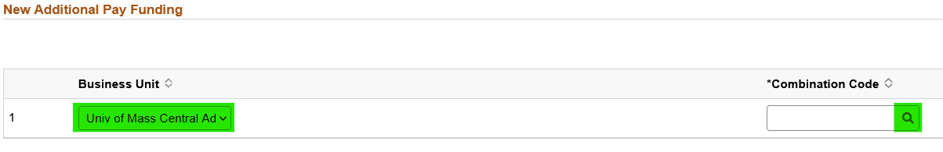
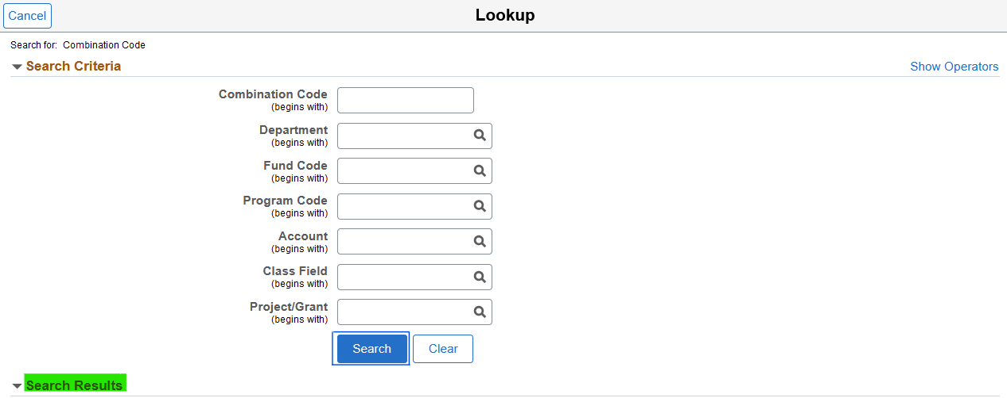

Next, upload any files/documents/emails associated with this Ad Comp. Note that if processing an addition compensation form for a grant funded employee there is a requirement for a document to be uploaded.
- ‘Add’ multiple files/documents/emails if needed
- ‘Delete’ any attachments incorrectly uploaded
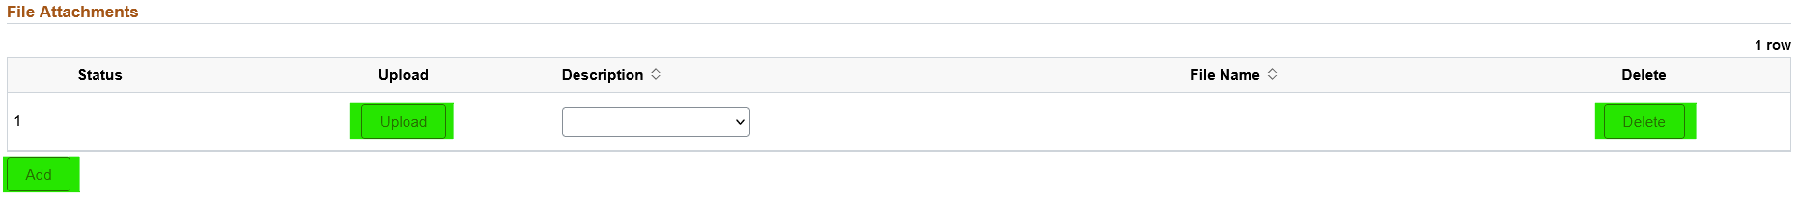

Next, add any Comments you feel are needed in addition to the above information already entered

Once the form has been fully completed, please hit Submit


What happens after I submit a form?
After Submit, the form goes through an approval workflow. The workflow varies slightly by campus. The following workflow is a general example.
Department Head/Chair > Division Head/Dean > Compensation > Payroll

Did you start a form but are unable to complete it immediately?
If you are unable to complete the form all at once, you do have the ability to ‘Save’ it and finish it later.
Click on the ‘Save’ button at the bottom of the page.

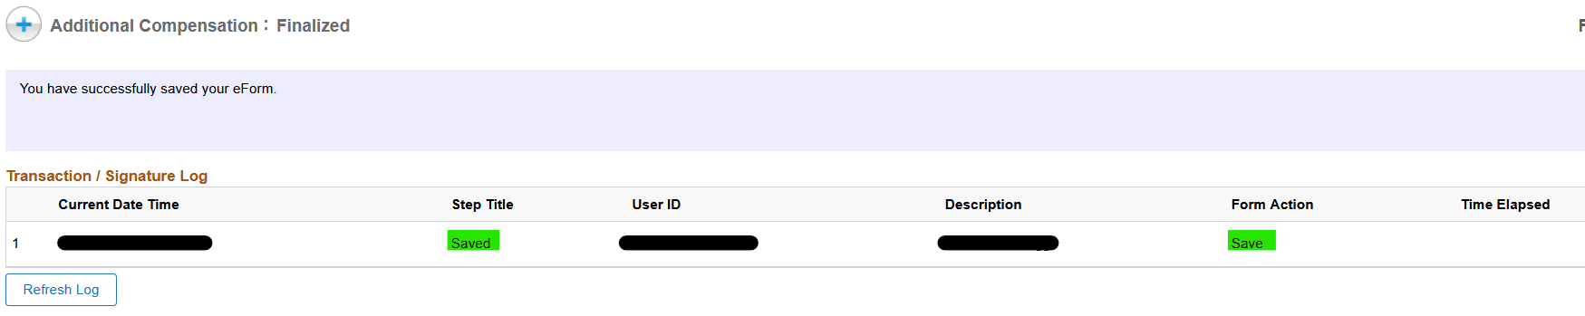
To continue inputting, go back to the Additional Compensation Landing Page and click on Update Request. Input your Form ID and/or Employee ID or First/Last Name and hit Search
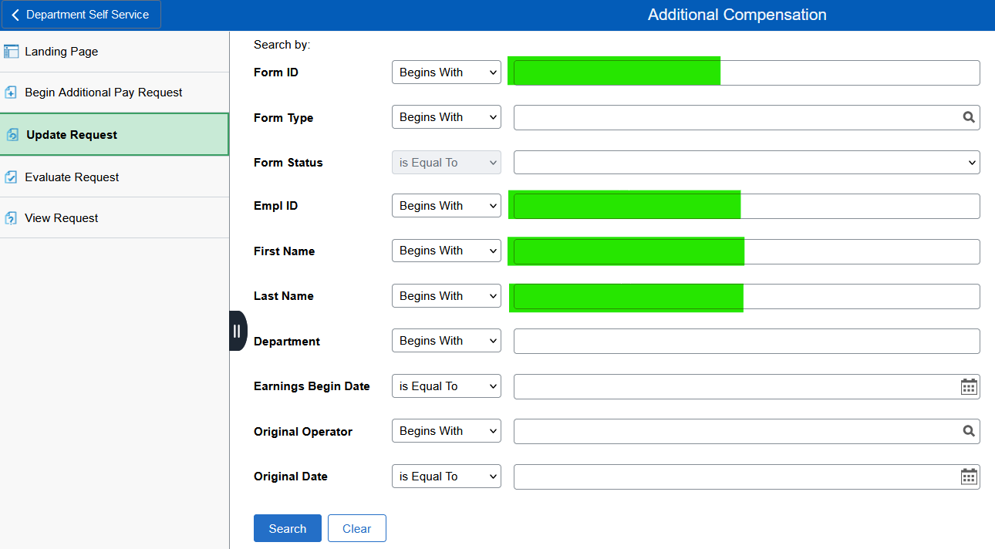
Continue inputting any missing data.

Where is the form pending? If you want to find out where the form is within the Workflow, go back to the Additional Compensation Landing Page and click on View Request

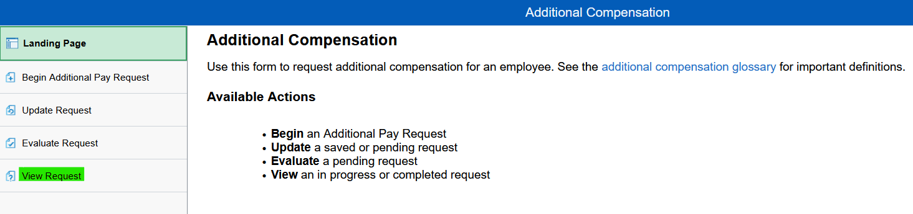

- Input Form ID or Employee ID or First/Last Name
- Click Search
  - If you input Form ID, the form will automatically open
  - If you input other search criteria, you may receive a list of forms created. Choose correct form
- Scroll to bottom of page and click Next
- Click on View Approval Route
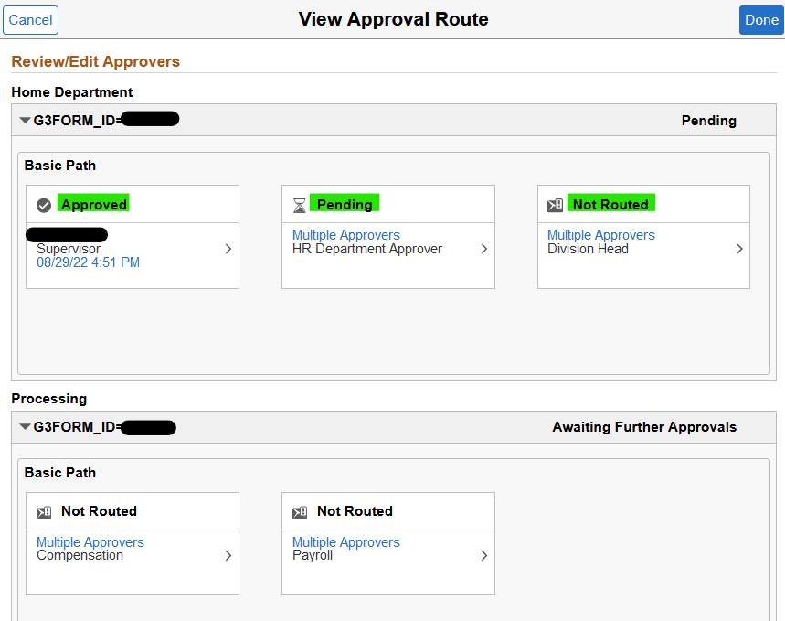
  - If Approval Box notes “Pending”, the form is waiting for this approver’s approval
  - If Approval Box notes “Not Routed”, the form will be routed once prior approvals are completed
  - If Approval Box notes “Approved”, the form has been successfully approved by that Approver
  - If the form has been Completed (Input into the HR Direct system), all sections will show as Approved, as shown below
