This document is to be used along with the Laser Audit form as a guide and cite the regulations of the ANSI Z136.1 standard.

Location of Laser System: ________________ Name of Laser User: ________________
Verified Laser User Training Complete: ____________ Date: ___/___/_______
- Before leaving to perform the laser survey you need to verify that the Authorized user has been trained and that their training is up to date as required: ANSI Z136.1 (2007) section 5.1: Training shall be provided to each employee routinely working with or potentially exposed to Class 3B or Class 4 lasers.
Authorization up to date:
- Before leaving Pinanski to perform the laser survey you need to verify that the lab you are about to survey has the lab authorization up to date. Authorized user has been trained and that their training is up to date as required:

Laser Class: _________ OD: _____ Wavelength: ___________nm
Laser Class: _________ OD: _____ Wavelength: ___________nm
Laser Class: _________ OD: _____ Wavelength: ___________nm

I. LASER POSTING, LABELING AND SECURITY MEASURES:
When performing this part of the survey you will be looking at the outside of the lab for postings, security, and entryway controls.

Entrance warning sign properly posted:
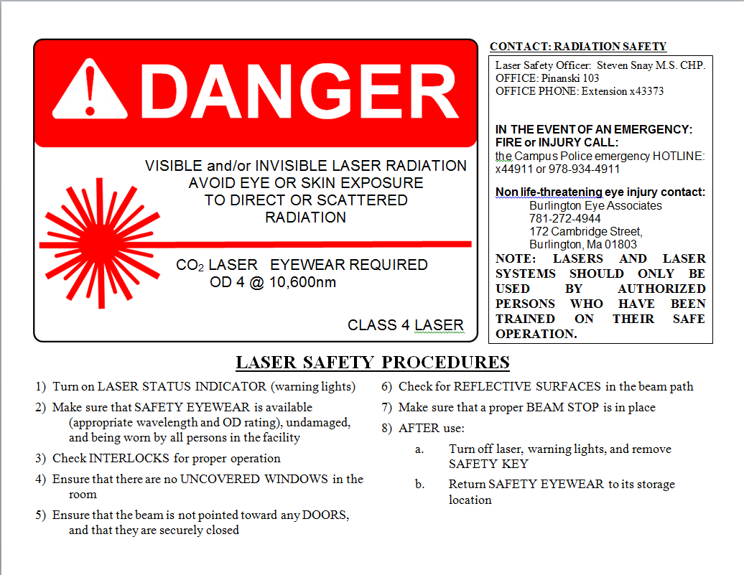
- ANSI Z136.1 (2007) section 4.3.9.1 “an area which contains a Class 3B or Class 4 Laser shall be posted as described in sections 4.3.10.1 and 4.3.10.2 (controlled area req. for class 3B and 4) with the appropriate sign described in section 4.7”(ANSI sign layout ). ANSI Z136.1 (2007) section 4.7.3.1 “The signal word Danger shall be used with all signs and labels associated with lasers of Class 3B and Class 4 lasers.”
- If the entrance is properly posted then check YES.

Room security adequate:
- ANSI Z136.1 (2007) section 4.3.7 “A Class 3B laser or laser system should and Class 4 laser or laser system shall be provided with a remote interlock connector. The interlock connector facilitates electrical connections to an emergency master disconnector interlock, or to a room, entryway, floor, or area interlock, as may be required for a Class 4 controlled area (see Section 4.3.10.2).”
- Entryway protective barriers: ANSI Z136.1 (2007) section 4.6.4 “A blocking barrier, screen, or curtain which can block or filter the laser beam at the entryway should be used inside the controlled area to prevent the laser light from exiting the area at levels above the applicable MPE. In some cases, where the barrier does not extend completely to the ceiling or to the floor, the LSO shall conduct an NHZ analysis to assure safety is afforded to all workers outside the barrier protected area. Laser barriers shall be specifically selected to withstand direct and diffusely scattered beams. The barrier shall exhibit a damage threshold for beam penetration for a specified exposure time commensurate with the total hazard evaluation for the facility and specific application (see Appendix C). Important in the selection of the barrier are the factors of flammability and decomposition products of the barrier material. It is essential that the barrier not support combustion or release toxic fumes following a laser exposure”.
- If the room with the laser inside is closed off with a laser barrier to form a new room, ensure there is only one entry to the laser room along with proper laser postings.
- If there is a laser barrier then ensure that the barrier provides adequate protection so there is no scatter outside of area.
- If these requirements have been met then check YES. If there is no barrier then check N/A. If there is more than one entryway and or the laser barrier does not provide proper protection then check NO and inform the LSO.

Entryway controls:
- ANSI Z136.1 (2007) section 4.3.10 “A laser hazard analysis shall be effected by the LSO. If the analysis determines that the classification associated with the maximum level of accessible radiation is Class 3B or Class 4, a laser controlled area shall be established and adequate control measures instituted (see Section 4.3.10.1 or 4.3.10.2). Note: The requirements for nonenclosed lasers or laser systems involving the general public are detailed in Section 4.5.1.
- ANSI Z136.1 (2007) section 4.3.10.1 “The Class 3B laser controlled area shall:
(1) Be controlled to permit lasers and laser systems to be operated only by personnel who have been trained in laser safety and in the operation of the laser or laser system. (see Section 5.5).
(2) Be posted with the appropriate warning sign(s) (see Section 4.7), except as detailed in Section 4.5.1.10. An appropriate warning sign shall be posted at the entryway(s) and, if deemed necessary by the LSO, should be posted within the laser-controlled area.
(3) Be operated in a manner such that the path is well defined
(4) Be well defined and controlled if the laser beam must extend outdoors and projects into a controlled airspace, particularly under adverse atmospheric conditions, e.g., rain, fog, snow, etc. (see Section 4.3.11.1 or 4.3.11.2).
In addition to the above, a Class 3B controlled area should:
(5) Be under the direct supervision of an individual knowledgeable in laser safety
(6) Be located so that access to the area by spectators is limited and requires approval, except as detailed in Section 4.5
(7) Have any potentially hazardous beam terminated in a beam stop of an appropriate material
(8) Have only diffusely reflecting materials in or near the beam path, where feasible
(9) Provide personnel within the laser-controlled area with the appropriate eye protection as specified in Section 4.6
(10) Have the laser secured such that the exposed beam path is above or below eye level of a person in any standing or seated position, except as required for medical use
(11) Have all windows, doorways, open portals, etc. from an indoor facility either covered or restricted in such a manner as to reduce the transmitted laser radiation to levels at or below the applicable ocular MPE
(12) Require storage or disabling (for example, removal of the key) of the laser or laser system when not in use to prevent unauthorized use.”
- ANSI Z136.1 (2007) section 4.3.10.2 “All Class 4 area or entryway safety controls shall be designed to allow both rapid egress by laser personnel at all times and admittance to the laser controlled area under emergency conditions. All personnel who require entry into a laser controlled area shall be appropriately trained, provided with appropriate protective equipment, and shall follow all applicable administrative and procedural controls (see Section 5). For requirements for spectators in a laser controlled area see Section 4.4.6.”
- ANSI Z136.1 (2007) section 4.3.10.2.2 “The Class 4 laser controlled area shall be designed to fulfill the items of Section 4.3.10.1 and in addition shall incorporate one of the following alternatives:
(1) Non-defeatable (non-override) Area or Entryway Safety Controls…
(2) Defeatable Area or Entryway Safety Controls (see below)…
(3) Procedural Area or Entryway Safety Controls (see below)…
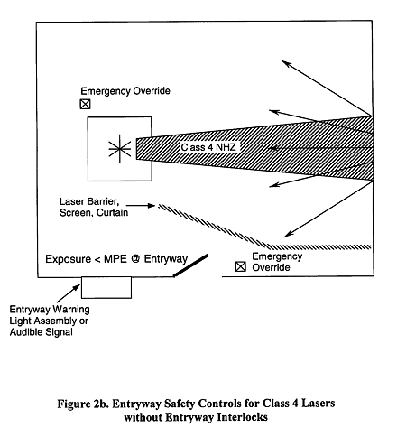
Where safety latches or interlocks are not feasible or are inappropriate, for example during medical procedures, surgery, etc., the following shall apply (see Figure 2b):
(a) All authorized personnel shall be adequately trained and adequate personal protective equipment shall be provided upon entry.
(b) A door, blocking barrier, screen, curtains, etc. shall be used to block, screen, or attenuate the laser radiation at the entryway. The level of laser radiation at the exterior of these devices shall not exceed the applicable MPE, nor shall personnel experience any exposure above the MPE immediately upon entry.
(c) At the entryway there shall be an activation warning system indicating that the laser is energized and operating at Class 4 levels (see 4.3.9.4).”

Door interlock system (defeatable/non-defeatable):
- Non-defeatable: ANSI Z136.1 (2007) section 4.3.10.2.2 Section 1 “ Non-defeatable (non-override) Area or Entryway Safety Controls. Non-defeatable safety latches, entryway or area interlocks (e.g., electrical switches, pressure sensitive floor mats, infrared, or sonic detectors) shall be used to deactivate the laser or reduce the output to levels at or below the applicable MPE in the event of unexpected entry into the laser controlled area (see Figure 2a).”
- Defeatable: ANSI Z136.1 (2007) section 4.3.10.2.2 Section 2 “Defeatable Area or Entryway Safety Controls. Defeatable safety latches, entryway, or area interlocks shall be used if non-defeatable area/entryway safety controls limit the intended use of the laser or laser system. For example, during normal usage requiring operation without interruption (e.g., long term testing, medical procedures, surgery), if it is clearly evident that there is no laser radiation hazard at the point of entry, override of the safety controls shall be permitted to allow access to authorized personnel provided that they have been adequately trained and provided with adequate personal protective equipment (see Figure 2a).”
- Figure 2a (below):
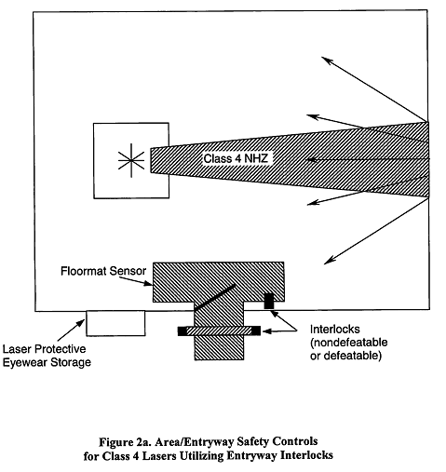

Entryway protected control zone:
- ANSI Z136.1 (2007) section 4.3.10.2.2 Section 3 “Procedural Area or Entryway Safety Controls. Where safety latches or interlocks are not feasible or are inappropriate, for example during medical procedures, surgery, etc the following shall apply (see Figure 2b): All authorized personnel shall be adequately trained and adequate personal protective equipment shall be provided upon entry. A door, blocking barrier, screen, curtains, etc. shall be used to block, screen, or attenuate the laser radiation at the entryway. The level of laser radiation at the exterior of these devices shall not exceed the applicable MPE, nor shall personnel experience any exposure above the MPE immediately upon entry. At the entryway there shall be an activation warning system indicating that the laser is energized and operating at Class 4 levels (see 4.3.9.4).”

Laser status indicator outside room:
- ANSI Z136.1 (2007) section 4.3.9.4 “An activation warning system should be used with Class 3B, and shall be used with Class 4 lasers or laser systems during activation or startup”
- ANSI Z136.1 (2007) section 4.3.9.4.2 “One form of visible warning device is a single red light or lighted laser warning sign that flashes when the laser is operating and is readably visible through laser protective eyewear and also viewable within the area. The light can be electrically interfaced and controlled by the laser power supply so that the light is on and flashing only when the laser is operating.
- If the laser status indicator is operable if so check YES.

II. EYEWEAR:
In this part of the survey you should write down the optical density and the pertinent wavelength of the eyewear as well as the number of the same eyewear. If there is more than one laser in the room and requires different sets of laser safety eyewear then you should write down the same information above for these sets of eyewear.

- ANSI Z136.1 (2007) section 4.6.2.1 Eye Protection (Class 3B or Class 4). Eye protection devices which are specifically designed for protection against radiation from Class 3B lasers or laser systems should be administratively required within the NHZ (above MPE) and their use enforced… Eye protection devices for Class 4 lasers or laser systems shall be administratively required and their use enforced when engineering or other procedural and administrative controls are inadequate to eliminate potential exposure in excess of the applicable MPE.

Laser eye protection available:
- Laser safety eyewear is readily available upon entering the room
- If laser safety eyewear is available then check YES.

Eyewear condition adequate:
- The eyewear was found to be in good condition and functioning properly. Eyewear was found to be of the sufficient optical density for the wavelength used in the lab.
- If laser safety eyewear is in adequate condition and is of proper optical density and wavelength then check YES.

III. LASER UNIT SAFETY CONTROLS:
In this part of the survey you will be looking specifically at the laser unit as a whole. Notify the LSO if there any parts of this survey checked no.

Laser hazard and class label in place:
- ANSI Z136.1 (2007) section 4.3.14.1 Warning Logotype Label for Equipment. “All lasers or laser systems (except Class 1) shall have appropriate warning labels (see Section 4.7.5) with the laser sunburst logotype symbol and the appropriate cautionary statement. The label shall be affixed to a conspicuous place on the laser housing or control panel. Such labels should be placed on both the housing and the control panel if these are separated by more than 2 meters.”
- CONTENT required: ANSI Z136.1 (2007) section 4.7.5 Pertinent Equipment Label Information:
  - “Equipment labels shall conform to the following specifications: Above the tail of the sunburst shall state for all Class 3B lasers and laser systems, “Laser Radiation – Avoid Direct Exposure to Beam.”
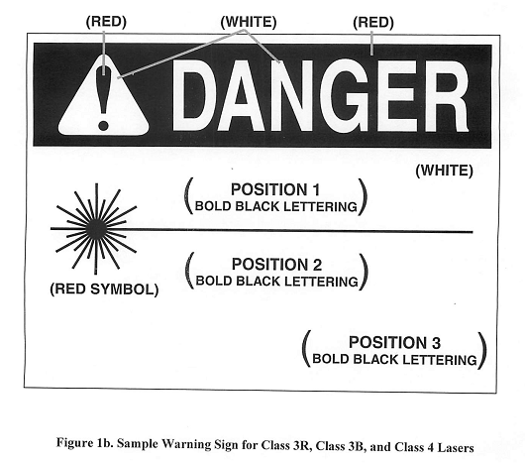
  - For Class 4 lasers and laser systems, “Laser Radiation – Avoid Eye or Skin Exposure to Direct or Scattered Radiation.” Below the tail of the sunburst shall be type of laser (Nd:YAG, Helium-Neon, etc.), or the emitted wavelength, pulse duration (if appropriate), and maximum output; and in the bottom right the class of the laser or laser system.
- ANSI Z136.1 (2007) section 4.3.14.3: Long Distance Beam Conduit Label “The LSO shall effect posting advisory protective housing labeling on long distance (>3 meters) beam conduits that contain beams operating above Class 1 levels. Such labeling shall be placed on the outside of the conduit at appropriate intervals (approximately 3 meters).
- Proper posting example (Right →)
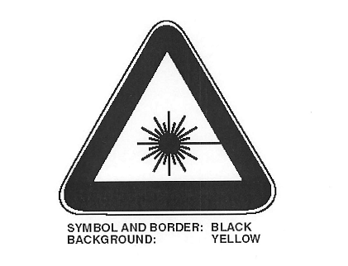
- If laser hazard label and class label is in place then check YES.

Laser aperture label in place:
- This is a label that points out where the laser is being emitted from.
- Posting example (Right→).
- If there is a laser aperture label is in place then check YES

Protective housing in place:
- ANSI Z136.1 (2007) section 4.3.1 “A protective housing shall be provided for all classes of lasers or laser systems”.
- This is the case that encloses the laser; it should not be damaged in anyway.
- If the protective housing is in place and not physically damaged then check YES.
- If a laser is operating without a protective housing inform the LSO immediately.

Laser not at eye level:
- Laser beam at eye level can increase the risk of eye injury therefore all chairs in the lab should position the occupant not eye level to the beam or the bench should be adjusted for height to prevent this condition.
- If the laser is at eye level but there is a protective barrier in between you and the laser then check YES for this section.
- If you were sitting in a chair would the laser be at eye level, if not then check YES.

Key Control should be present:
- At this step we are looking for a key that controls if the laser is on or off.
- ANSI Z136.1 (2007) section 4.3.4 “a class 3B or Class 4 laser or laser system should be provided with a master switch”. It is good work practice to disable the laser by removing the key and maintaining it in a secure location where it is only accessed by the properly trained laser user.”
- If key control is present then check YES.

Laser activation indication on console:
- We are looking to see if an indicator light is present on the laser system.
- ANSI Z136.1 (2007) section 4.3.9.4 “An activation warning system should be used with Class 3B, and shall be used with Class 4 lasers or laser systems during activation or startup.”
- An indication may be on the laser console but is acceptable if visible somewhere else in the room.
- If a laser activation indication is present then check YES.

IV. ENGINEERING SAFETY CONTROLS:
In this part of the survey focus on the safety aspects of the lab. This is where it is important to make sure that everything before the optional information section is checked yes. If not inform the LSO immediately. Optional information does not need to be checked yes; however, if checked no, then make note in the comments.

Emergency shutoff available:
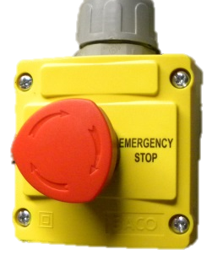
- ANSI Z136.1 (2007) section 4.3.10.2.1 Emergency Conditions. For emergency conditions there shall be a clearly marked “Emergency Stop” or other appropriately marked device appropriate for the intended purpose (remote controlled connector or equivalent device) available for deactivating the laser or reducing the output to levels at or below the applicable MPE.
- Look for an emergency stop switch, button, or circuit breaker properly marked.
- If at least one is present then check YES.

Laser and optics secured to table:
- Check to see if the laser and optics are all properly bolted down to the laser table; this helps prevent any stray beams. This will also prevent the laser and optics from moving if someone bumps into them.
- If the laser and optics are secured to the table, then check YES.

Reflective materials kept out of beam path:
- Look at the beam path that the laser travels through. Does this path either come across, or have the potential to hit a reflective material causing stray beams? If so inform the Authorized User (AU) and/or the LSO to fix the situation.
- If the beam path is clear from reflective material then check YES.
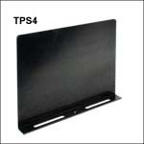
Beam barriers in place:
- These are usually black sheets of metal that are typically at the edge of the table preventing any stray beams from escaping.
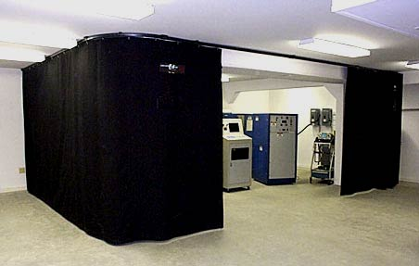
- 4.6.5 Labeling of Protective Equipment (Class 3B or Class 4). All protective equipment shall be permanently labeled as specified in ANSI Z136.1 (2007) section 4.6.5.4 “All laser protective barriers sold other than as an integral part of a product shall be labeled with the barrier exposure time for which the limit applies and the beam exposure conditions under which protection is afforded (see Appendix C2.4).”
- If the barriers are in place and provide adequate shielding then check YES.

Interlock present on embedded class 3B or 4 lasers:
- ANSI Z136.1 (2007) section 4.3.2 “Protective housings which enclose Class 3B and Class 4 lasers or laser systems shall be provided with an interlock system which is activated when the protective housing is opened or removed during operation and maintenance.”
- ANSI Z136.1 (2007) section 4.3.3 “Portions of the protective housing that are only intended to be removed from any laser or laser system by service personnel, which then permit direct access to laser radiation associated with a Class 3B or Class 4 laser or laser system, shall either:
- Be interlocked (fail-safe interlock not required), or
(2) Require a tool for removal and shall have an appropriate warning label (see Section 4.7) on the panel.
If the interlock can be bypassed or defeated, a warning label with the appropriate indications shall be located on the protective housing near the interlock (see Section 4.7). The label shall include language appropriate to the laser hazard. The interlock design shall not permit the service access panel to be replaced with the interlock remaining bypassed or defeated.”
- User created enclosures requires interlocks. ANSI Z136.1 (2007) section 4.3.1 “If a user-created enclosure does not meet the requirements of a protective housing (e.g., a non-interlocked cover or bolted access panels), it shall be considered as a barrier or curtain and other controls are required per Section 4.3.1.1.” Then check N/A for not applicable.
- If there are interlocks present on the laser or laser system then check YES.

Beam stops in place:
- ANSI Z136.1 (2007) section 4.3.8 “A class 4 laser shall be provided with a permanently attached beam stop or attenuator” while “A class 3B laser should be provided with a permanently attached beam stop”
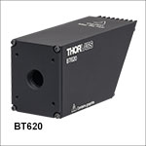
- The LSO shall determine if the beam stops is adequate for scattered laser radiation.
- Beam Stop example (Right →):
- Check to see if there are permanent beam stops for all class 4 lasers. If yes then check YES. If there is not a permanent beam stop then inform the LSO immediately.
- If the laser is a 3B laser then check to see if there is a permanent beam stop. If not then check NO and make notes “Class 3B” in the comment section.

Windows in room covered:
- ANSI Z136.1 (2007) section 4.3.10.1 “a Class 3B controlled area should: Have all windows, doorways, open portals, etc. from an indoor facility either covered or restricted in such a manner as to reduce the transmitted laser radiation to levels at or below the applicable ocular MPE”
- ANSI Z136.1 (2007) section 4.6.3 “Facility windows (exterior or interior) that are located within the NHZ of a Class 3B or Class 4 laser or laser system shall be provided with an appropriate absorbing filter, scattering filter, blocking barrier, or screen which reduces any transmitted laser radiation to levels below the applicable MPE”
- It is highly recommended that the windows should be covered if windows are covered then check YES.
- If there are windows that do not have any protective covering from laser or stray beams and are necessary then inform the LSO immediately.

No physical evidence of stray beams:
- Look for any physical evidence of stray beams (burn marks), if there are no new burn marks then check YES.

Optional Information:
These following steps in the survey do not need to be checked yes. If checked no, then notes should be made in the comments line.
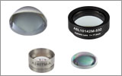
Beam condensed or enlarged:
- If the laser go through any optics that makes the beam smaller or larger check YES. If there are no diverging optics that the laser passes through then check N/A.

Beam intensity reduced through filtration:
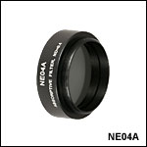
- ANSI Z136.1 (2007) section 4.6.5.3 “All permanently mounted collecting optics housings containing laser protective filters sold other than as an integral part of a product shall be labeled with the optical density and wavelength(s) for which protection is afforded (see Section 4.6.2.5). All collecting optics filter housings should also be labeled with the threshold limit (TL) and exposure time for which the limit applies and the conditions under which protection is afforded.”
- Beam filter example: (Right →)
- If the laser goes through a filter to reduce its power then check YES. If there is no filter then check N/A.

Fiber optics in use:
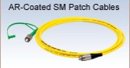
- If fiber optic cables are being used in the laser lab then check YES. If fiber optics are not being used check N/A.
- Fiber optics example: (right →)
- Note: fiber optic wires must be posted with a laser warning logo.

Beam path enclosed:
- ANSI Z136.1 (2007) section 4.3.6.3 “ In applications where the entire beam path is enclosed, an enclosure fulfills the requirements of a protective housing”
- ANSI Z136.1 (2007) section 4.3.6.2 “ In applications of Class 3B or Class 4 lasers where the beam is confined by design to significantly limit the degree of accessibility of the open beam, a hazard analysis shall be effected by the LSO”
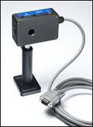
http://photonics.com/Article.aspx?AID=42653
Beam shutter functioning:
- Look for a beam shutter (Right→) located near the laser aperture so the laser beam can be stopped. If there is a shutter present and functioning then check YES. If there is no beam shutter present then check N/A.

Beam power meter:
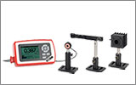
- Look for a beam power meter which will be located near the laser or on a computer hooked up to a laser.
- Laser beam power meter: (Right →)
- If there is a beam power meter present and functioning then check YES. If there is no beam power meter then check N/A.

V. ADMINISTRATIVE SAFETY CONTROLS:
In this section of the survey you are looking for the Administrative safety controls, which are methods or instructions to specify rules, work practices, or both. They supplement engineering controls and may specify the use of personal protective equipment that each laser lab shall have and maintain. These controls should be readily available in case of emergencies. The follows steps in the survey should be checked off as yes. If there are any NO check marks then inform the LSO.

Emergency contact list up to date and posted:
- The Radiation Safety office has contact information posted on the door posting and the lab personal shall have their contacts either posted on the wall or in the CHP (chemical hygiene plan).
- Check to see if there is a posting of the emergency contact list.
- Check to see if the list is up to date.
- If there list is posted and up to date then check YES, if not check NO.

Laser safety guidelines posted:
- The Radiation Safety office has Laser safety guidelines included as part of the door posting.
- If the laser safety guidelines are posted then check YES.

Laser safety policy manual available:
- Check to see if the laser safety policy manual is present in the lab, if so then check YES.

Lab specific SOP’s up to date:
- ANSI Z136.1 (2007) section 4.4.1 Standard Operating Procedures (Class 3B or Class 4). The LSO should require and approve written standard operating, maintenance and service procedures (SOPs) for Class 3B lasers or laser systems. The LSO shall require and approve written SOPs for Class 4 lasers or laser systems. These written SOPs shall be maintained with the laser equipment for reference by the operator, and maintenance or service personnel (see Section 4.4.5).
- Each lab has a specific SOP, check to see if the SOP is present, up to date, and for the correct lab that you are in.
- If the SOP are posted and for the correct lab as well as up to date then check YES.

Lab specific Alignment procedures:
- ANSI Z136.1 (2007) section 4.4.5 “Written standard operating procedures (SOPs) outlining alignment methods should be approved for Class 3B and shall be approved for Class 4 lasers or laser systems. SOPs shall also be applicable for all classes of lasers or laser systems which contain embedded Class 3B or Class 4 lasers under conditions which would allow access during alignment procedures”.
- ANSI Z136.1 (2007) section 4.4.5 “Alignment of Class 2, 3R, 3B, or Class 4 laser optical systems (mirrors, lenses, beam deflectors, etc.) shall be performed in such a manner that the primary beam, or a specular or diffuse reflection of a beam, does not expose the eye to a level above the applicable MPE (see Section 4.6.2.5.2(3)). There are many instances, such as during service, when a temporary beam attenuator placed over the beam aperture can reduce the level of accessible laser radiation to levels at or below the applicable MPE”.
- Each lab is required to have a lab specific alignment plan in place, ensure that the lab has the up to date and correct copy of the laser alignment procedure. If so then check YES.

Proper skin protection available:
- ANSI Z136.1 (2007) section 4.6.2.2 « UV Laser Protection. Particular care shall be taken when using UV lasers or laser systems. Thus, in addition to other laser controls which apply to all laser systems, the following requirements shall also apply. Exposure to UV radiation shall be minimized by using beam shields and clothing which attenuate the radiation to levels below the applicable MPE for the specific UV wavelengths… Personal Protective Equipment (PPE), shall be used when working with open beam Class 3B or Class 4 UV lasers. This shall include both eye and skin protection.”
- If there is proper skin protection for UV laser then check YES.
- If there are no UV lasers in the lab then check N/A.

VI. NON-BEAM HAZARDS:
Non-beam hazards are a class of hazards that do not result from direct human exposure to a laser beam. Non-beam hazards include physical, chemical, and biological agents. Non-beam hazards may occur when a material is exposed to a laser beam (e.g., fire or airborne contaminants); when materials used to generate the beam (e.g., flow-through gases, dyes and solvents) are released into the atmosphere; or when individuals contact system components (e.g., shock or electrocution). In some cases, these hazards can be life threatening (e.g., electrocution). As a result, the hazards discussed in this section require use of control measures. Also, all written SOPs shall address non-beam hazards as well as beam hazards. Because of the diversity of non-beam hazards, the LSO may employ safety and/or industrial hygiene personnel to effect evaluations.

General housekeeping: (tripping hazards, cluttered optics table, etc.):
- Look at the lab you are surveying. The lab should not be cluttered and there should not be any tripping hazards. Note the condition that the lab is in the comment section.
- Acceptable conditions:
  - CLEAN: the lab is in good condition, plenty of open space with no possible tripping hazards.
  - FAIR: the lab is moderately cluttered, but still in a safe working condition.
  - MESSY: the lab poses potential safety hazards. Hazards included tripping, beam scatter off of clutter (material potentially falling into the beam).

A YES response for the items below indicates that the hazard is handled safely:
Any NO responses shall be reported to the LSO and the Authorized User.

Fire hazards (Class 4 only):
- ANSI Z136.1 (2007) section 7.2.3 “Class 4 laser beams represent a fire hazard. Enclosure of Class 4 laser beams can result in potential fire hazards if enclosure materials are likely to be exposed to irradiances exceeding 10 W*cm^-2 or beam powers exceeding 0.5 W”.
- Check to see if there any materials that can catch on fire located near the lasers beam path.
- This section applies to Class 4 lasers only. Check the N/A box if there is no class 4 laser present for the survey.
- If there are no fire hazards present then check YES.

LGAC production (Class 4 only):
- ANSI Z136.1 (2007) section 7.3.1 “Air contaminants may be generated when Class 4 laser beams interact with matter. The quantity, composition, and chemical complexity of the LGAC depend greatly upon target material, cover gas, and the beam irradiance. The LSO shall ensure that industrial hygiene aspects of exposure to LGAC are addressed and that appropriate control measures are affected”.
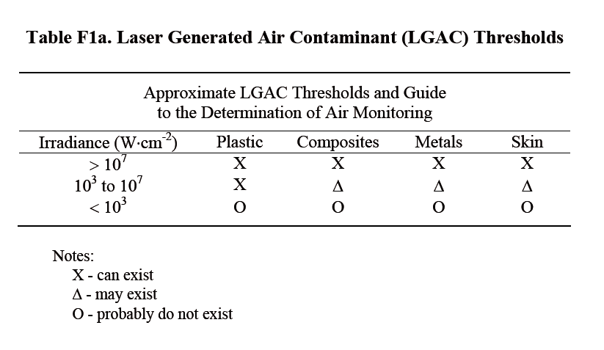
- ANSI Z136.1 (2007) section 7.3.1 “While it is difficult to predict what LGAC may be released in any given interaction situation, it is known that contaminants, including a wide variety of new compounds, can be produced with many types of lasers. When the target irradiance reaches a given threshold, approximately 10^7 W*cm^-2 (see Table F1(a) in Appendix F), target materials including plastics, composites, metals, and tissues may liberate carcinogenic, toxic and noxious airborne contaminants. The amount of the LGAC may be greater for lasers that have most of their energy absorbed at the surface of the material”.

- This section applies to Class 4 lasers only. Check the N/A box if there is no class 4 laser present for the survey.
- If there are no LGAC then check YES.

Possible electrical shock:
- ANSI Z136.1 (2007) section 7.2.1.1 “The use of lasers or laser systems can present an electric shock hazard. This may occur from contact with energized electrical conductors contained in device control systems, power supplies, and other devices that operate at potentials of 50 volts and above. These exposures can occur during laser set up or installation, maintenance, modification, and service, where equipment protective covers are often removed to allow access to active components as required for those activities. Those exposed can be equipment installers, users, technicians, and uninformed members of the public, such as passersby”.
- Check around the room looking for any possible electrical hazards. If there are no hazards then check YES.

Collateral radiation hazard:
- ANSI Z136.1 (2007) section 7.2.2 “Collateral radiation is radiation other than that associated with the primary laser beam and is produced by system components such as power supplies, discharge lamps and plasma tubes. Such radiation may take the form of x-radiation, UV, visible, IR, microwave and radio-frequency (RF) radiation. Plasma radiation is generated when an energetic laser beam interacts with matter, typically metals. This occurs when high power pulsed laser beams (peak irradiance of the order of 10^12 W*cm^-2) are focused on a target”.
- Check the lab for any potential collateral radiation hazards, if there is no collateral radiation hazards then check YES.

Explosion hazards:
- ANSI Z136.1 (2007) section 7.2.4 “High-pressure arc lamps, filament lamps, and capacitor banks in laser equipment shall be enclosed in housings which can withstand the maximum explosive pressure resulting from component disintegration. The laser target and elements of the optical train which may shatter during laser operation shall also be enclosed or equivalently protected to prevent injury to operators and observers. Explosive reactions of chemical laser reactants or other laser gases may be a concern in some cases.”
- Check the lab for any potential explosion hazards, if there is no explosion then check YES.

Cryogen handling:
- Check to see if the lab is handling cryogens safely. A safe handling procedure should be found in the labs’ CHP.
- If handling equipment is acceptable and the procedure is present then check YES.
- If there are no cryogens in the lab then check N/A.

Compressed gases:
- Check to see if the lab is handling compressed gases safely. A safe handling procedure should be found in the labs’ CHP.
- Check to see if the cylinders are properly secured in the lab.
- If gases are properly stored and the procedure is present then check YES.
- If the lab does not contain any compressed gases then check N/A.

Toxic laser media:
- Laser dyes and solvents can be highly toxic and/or carcinogenic and must be handled safely.
- ANSI Z136.1 (2007) section 7.3.3 “Dye lasers containing at least 100 milliliters of flammable liquids shall be in conformance with the provisions of the NFPA (NFPA 30 and 45), and the NEC (Article 500 – Hazardous (classified) Locations).”
- “Laser dyes shall be prepared in a laboratory fume hood.” ANSI Z136.1 (2007) section 7.3.3.
- “Dye pumps and reservoirs should be placed in secondary containment vessels to minimize leakage and spills in conformance with NFPA 115.” ANSI Z136.1 (2007) section 7.3.3
- If media is safely handled in a working fume hood in secondary containment vessels then check yes.
- If the lab does not contain any toxic laser media then check N/A.

Fume hood working:
- Check to see if the fume hood is functioning properly if so then check YES.
- If there is no fume hood present then check N/A.

VII. NEW LASER SYSTEM INFORMATION:
This section is to be used when there is a new laser system in the room you are surveying. Fill out the sections on the survey and inform the LSO of the new laser system in the room.

