Overview and Navigation
Employee who are on a paid Family Medical Leave and have paid time off (sick, vacation, personal, etc.) should report that time each week while they are out on Family Medical Leave (FMLA). Paid time off for Family Medical Leave puposes must be identified by entering the FMLA companion code (information only code). This code identifies your time off as related to an FMLA leave.

Reporting Time
Navigation: Self Service > Time Reporting > Report Time > Timesheet
Employee on a Full Family Medical Leave:

Use the Timesheet page to enter time, time off for all scheduled work days along with the FMLA companion code.

Example 1
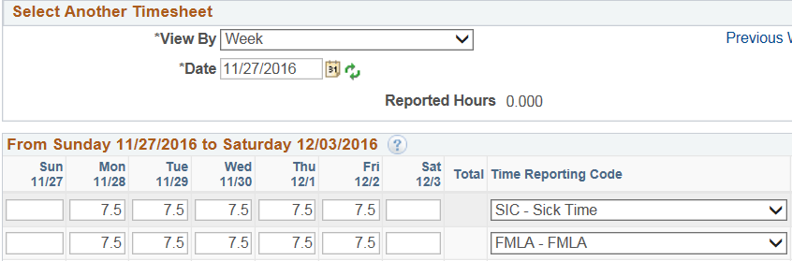

Example 2
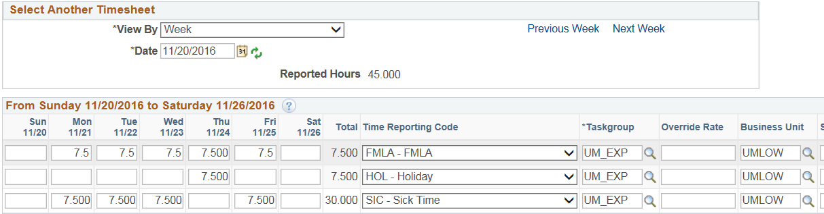

Employee on a Partial Intermittent Family Medical Leave:

Use the Timesheet page to enter time off. When time off is associated with the Family Medical Leave Act enter the FMLA companion code.

Example 1

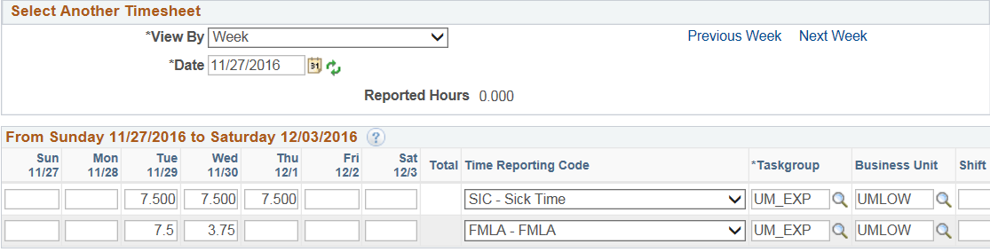

Click Submit: Click to process the timesheet. Once submitted, a confirmation page will display stating your time has been successfully entered requiring you to click OK.

chri

