Electronic Additional Compensation (eAddl Pay) – Frequently Asked Questions (FAQ)

- What does the Paid YTD Total % mean?
  - This represents the year-to-date total of additional compensation already paid to the employee. This does not include any additional compensation that has already been processed by HR/Payroll and that is still paying out (pending). This amount also does not include any additional compensation that has been processed by HR/Payroll for a future pay cycle.

- How do I know what the employees’ 33% or 12% limit is?
  - The top left of the form shows the employee’s current annual salary. You can find the limit by using these calculations.
    - Annual salary and divided by 3 for the 33% limit
    - Annual salary and divided by 0.12 for the 12% limit.

- Is the Earnings field the total amount to be paid to the employee?
  - Yes, the amount of earnings entered on the form is the total amount to be paid to the employee.

- How should I complete the “How did you arrive at this amount?” field?
  - Provide a clear and concise explanation of how the total rate of pay or hourly rate of pay was determined. Please list the flat amount total to be paid, as well as the math that backs up that total. Example: MSP rate of $ XXX.XX, clarify if this rate has per hour, day, etc.

- How should I complete the “Provide a Detailed Description the services and justification of services….” field?
  - Use a detailed comment clearly identifying the reason for the work in the following format: Begin description with a clear reason for the additional compensation, such as:
    - Teaching: SU25, CHEM.1929.046. Credits 3
    - Course Development: Development of Course XXXXXXXXXXXXX
    - Course Overload: SU25, CHEM.1929.046. Credits 3
  - Other “Reasons” examples below:
    - ARPA:
    - Advising:
    - Assessment:
    - Benefits Administration Credit:
    - Contract Payout:
    - Course Development:
    - Course Overload:
    - Faculty Start Up:
    - Other/Misc:
    - Professional Development:
    - Program Coordinator/Director:
    - Project:
    - Research:
    - Seminar:
    - Royalty:
    - Student Advising:
    - Summer Activities:
    - Teaching:
    - Training:
6. How are revised increases handled?
- Revised increases must be submitted using a new electronic additional pay form. Please use the “Provide a Detailed Description the services and justification of services….” section to note that this is a revised form. Please refer to the original form number when submitting a revised increase. I.e. “Form ID 104328 Revision”
- Commitment amount on revised form should be the difference of the increase of the original form.
7. How do I submit a decrease to a previously submitted form?
- Decreases should be communicated directly to HR/Payroll. Do not submit a new form for decreases.
8. Once a form has been submitted can a form be withdrawn?
- Yes, a form can be withdrawn by the form initiator if the form has not yet been executed by HR/Payroll.
9. What should I do if I need to cancel a form that has already been executed?
- If the form needs to be cancelled after it has been executed, please contact HR/Payroll immediately. HR/Payroll will require an email to be submitted that will be uploaded into the original form noting the cancellation.
10. What happens if an employee exceeds the 33%/12% pay threshold?
- The campus policy has clear limits. Information is available at: https://www.uml.edu/HR/Labor-Relations/
  - Forms submitted for employees who are over their 33% threshold will be routed to the Provost for approval. Please note that this occurs if the “Paid YTD Total% is at or above 33%.
  - Forms submitted for employees who are over their 12% threshold will require review and approval by the Benefits & Compensation Team.
  - 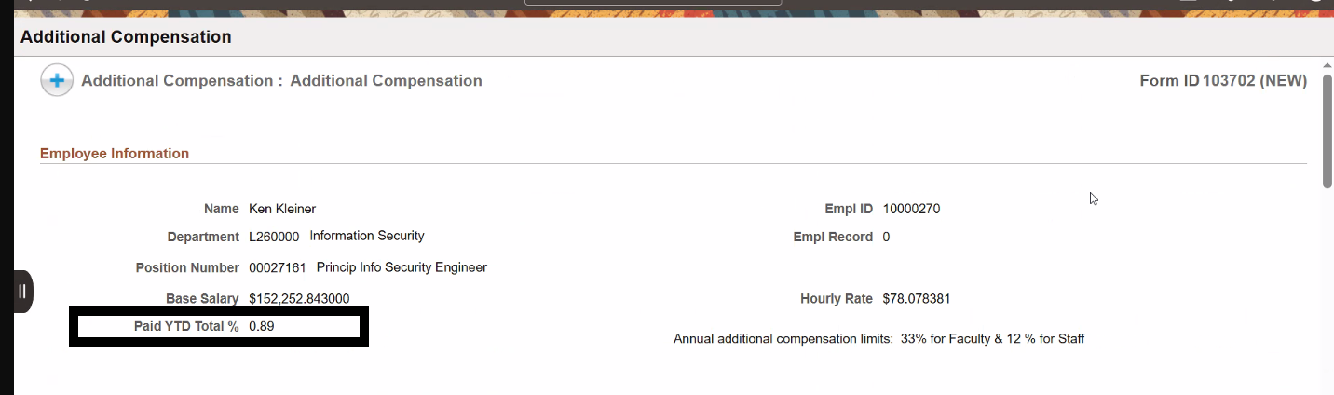

11. What documentation is needed to exceed the 12/33% pay limit?
- If an employee has exceeded or will exceed their 12% or 33% limit, you must upload additional documentation into the form to support the request. Please reach out to Benefits & Compensation Team for more information.
- Forms that show that an employee is below the 33% threshold, but the additional compensation form being processed will push them over that threshold, do not automatically go to the provost for approval. Initiators should be aware of these cases, and attach additional documentation into the additional compensation form showing that prior approval from the Provost has been sought and received. This approval documentation should be uploaded into the form using the upload document feature.
12. What does it mean if I see ‘”Existing Additional Pay” within a form?
- This indicates the employee has current active payments. Please review all existing payment details to avoid submitting duplicate payments.
- 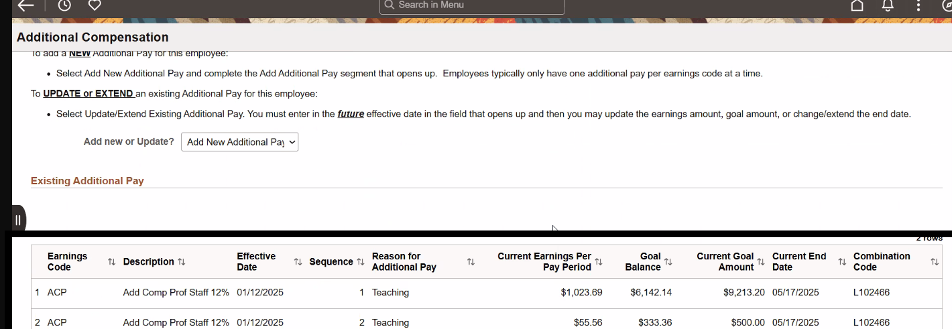

13. Why might a completed payment not appear on the form?
- Once a payment has been fully processed and completed, it will no longer appear on the form.

